Nexelus Configuration:

* First run the TTD script “new_ttd_client_integration.sql” on IPC DB.
* In Company -> IPC Integration tab add the new record using the “Access Tag” and rest of the information just created through scripts.
  + **AdTool** – TradeDesk
  + **Account ID** – 601
  + **User ID** – TradeDeskBilling
  + **Password** – password
  + **Access Tag** – “From the script”
  + **Ad Tool Category** – TradeDesk Billing API
    - If ad tool category is not shown in the drop down, then please check the company rule “**CompanyRules/Billing/IntegrationServices/AdToolBilling**” and make sure that “Search: TradeDesk” is selected.
  + Make sure the Ad Tool added is active for it to work.

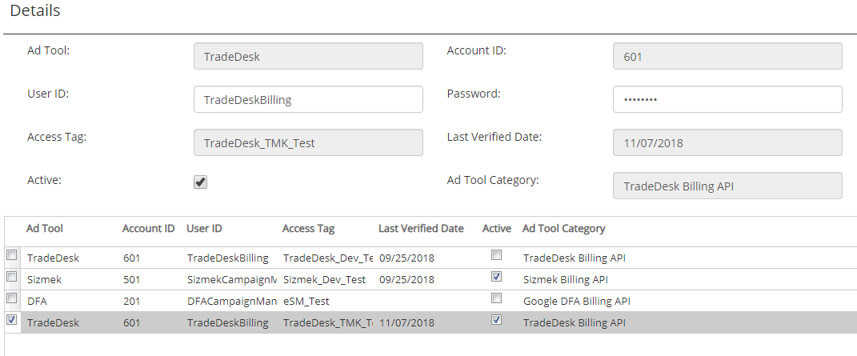

* After this setup run the script “**ttd_nexelus_setup.sql**”.
* There are company rules which defines which Trade Desk Field (partner id, advertiser id) will be mapped to which screen.
  + CompanyRules/Billing/IntegrationServices/Mapping/TradeDeskBilling/PartnerID
  + CompanyRules/Billing/IntegrationServices/Mapping/TradeDeskBilling/AdvertiserID
* These rules needs to be set prior to be able to configure TTD partner/advertisers to Client Profile.